WEB DEVELOPMENT PERSONAL PROJECT

TrackIT
A full stack web app used to track bugs of a project with basic CRUD functionality. Created using MERN stack and Material UI.

Space Tourism
A frontend mentor project to build the website identical to the provided Figma design. Technology that is used to build the project is React, React-router, CSS, BEM. The project served as a practice to build and structure a react project.

WORK EXPERIENCE

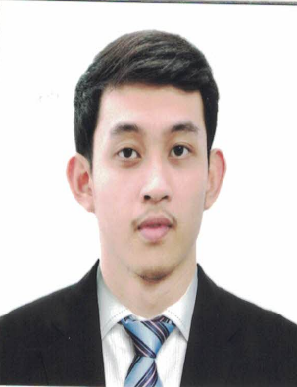RICOHERMOSO M. MERCADO
 ^{mercado.ricohermoso@gmail.com}
 ^{github.com/mercadorico}
 ^{linkedin.com/in/rico-mercado}
 ⁺⁶³ ⁹⁶⁶ ³⁴⁸ ⁷²⁵⁵

SKILLS AND INTEREST
Software/Web Development
HTML, CSS, JavaScript, React, Material UI, Git, Redux

Electronics Bench Equipment
Able to use Oscilloscope, Power Supply, Multimeter, Source Meter

ATE Systems
Teradyne Flex, NI-STS Test Stand, CTS

Data Analytics
JMP, Data tool(in house)

Analog Devices Inc., Test/Product Engineer
Gateway Business Park, General Trias, Cavite
December 2018 – Present
- Optimize test programs in production to ensure quality products.
- Sustain performance of linear products in IC test manufacturing.
- Data analysis using statistical tools to review product performance.
- Quality and cost initiatives (Test Time Reduction/Yield Improvement).
- Responsible for yield analysis and reduction of outgoing defect level.
- Perform electrical characterization analysis thru ATE and bench.
- Provide timely disposition on non-conforming lots.
- Analyze problems to identify root cause & implement corrective action
- Test program or software debugging in ATE platform.
- Experience with C/C++ ATE test programs.
INTERNSHIP
Maxim Integrated, Test Systems Engineering Intern
Gateway Business Park, General Trias, Cavite
August 2017 – January 2018
- Familiarize semiconductor test manufacturing.
- Assist Test Engineers on hardware debug.
- Introduction to non-ATE testing and calibration.
EDUCATIONAL BACKGROUND
First Asia Institute of Technology and Humanities
#2 Pres. Laurel Highway, Darasa, Tanauan City, Batangas 4232
June 2013 – June 2018
Bachelor of Science in Electronics Engineering
ACHIEVEMENTS AND AW7ARDS

